EXPERIMENT 32 – WEB BLOG USING WORDPRESS

AIM
To create a simple web blog using WordPress and demonstrate title, heading, paragraph, image, and anchor tags.

ALGORITHM
- Start WordPress and create a new blog.
- Enter the required title and headings.
- Add paragraphs containing the required content.
- Insert an image and hyperlink.
- Publish and verify the blog.

PROGRAM
<!DOCTYPE html>
<html>
<head>
<title>My Technology Blog</title>
</head>

<body>

<h1>Artificial Intelligence</h1>

<p>
Artificial Intelligence enables computers to perform
tasks that normally require human intelligence.
</p>

<img src="ai.jpg" width="400" height="250">

<h2>Applications of AI</h2>

<p>
AI is used in healthcare, education, banking, robotics
and transportation.
</p>

<p>
Learn more about AI:
<a href="https://www.wikipedia.org">Click Here</a>
</p>

</body>
</html>

OUTPUT

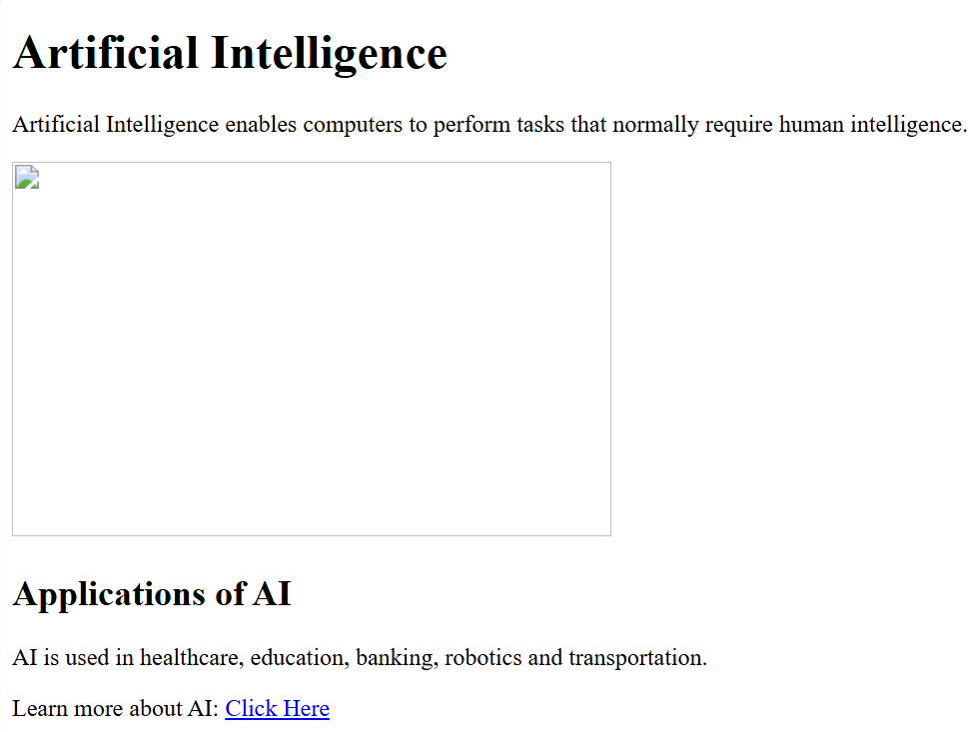

RESULT
Thus, the web blog was successfully created with the required HTML elements.

